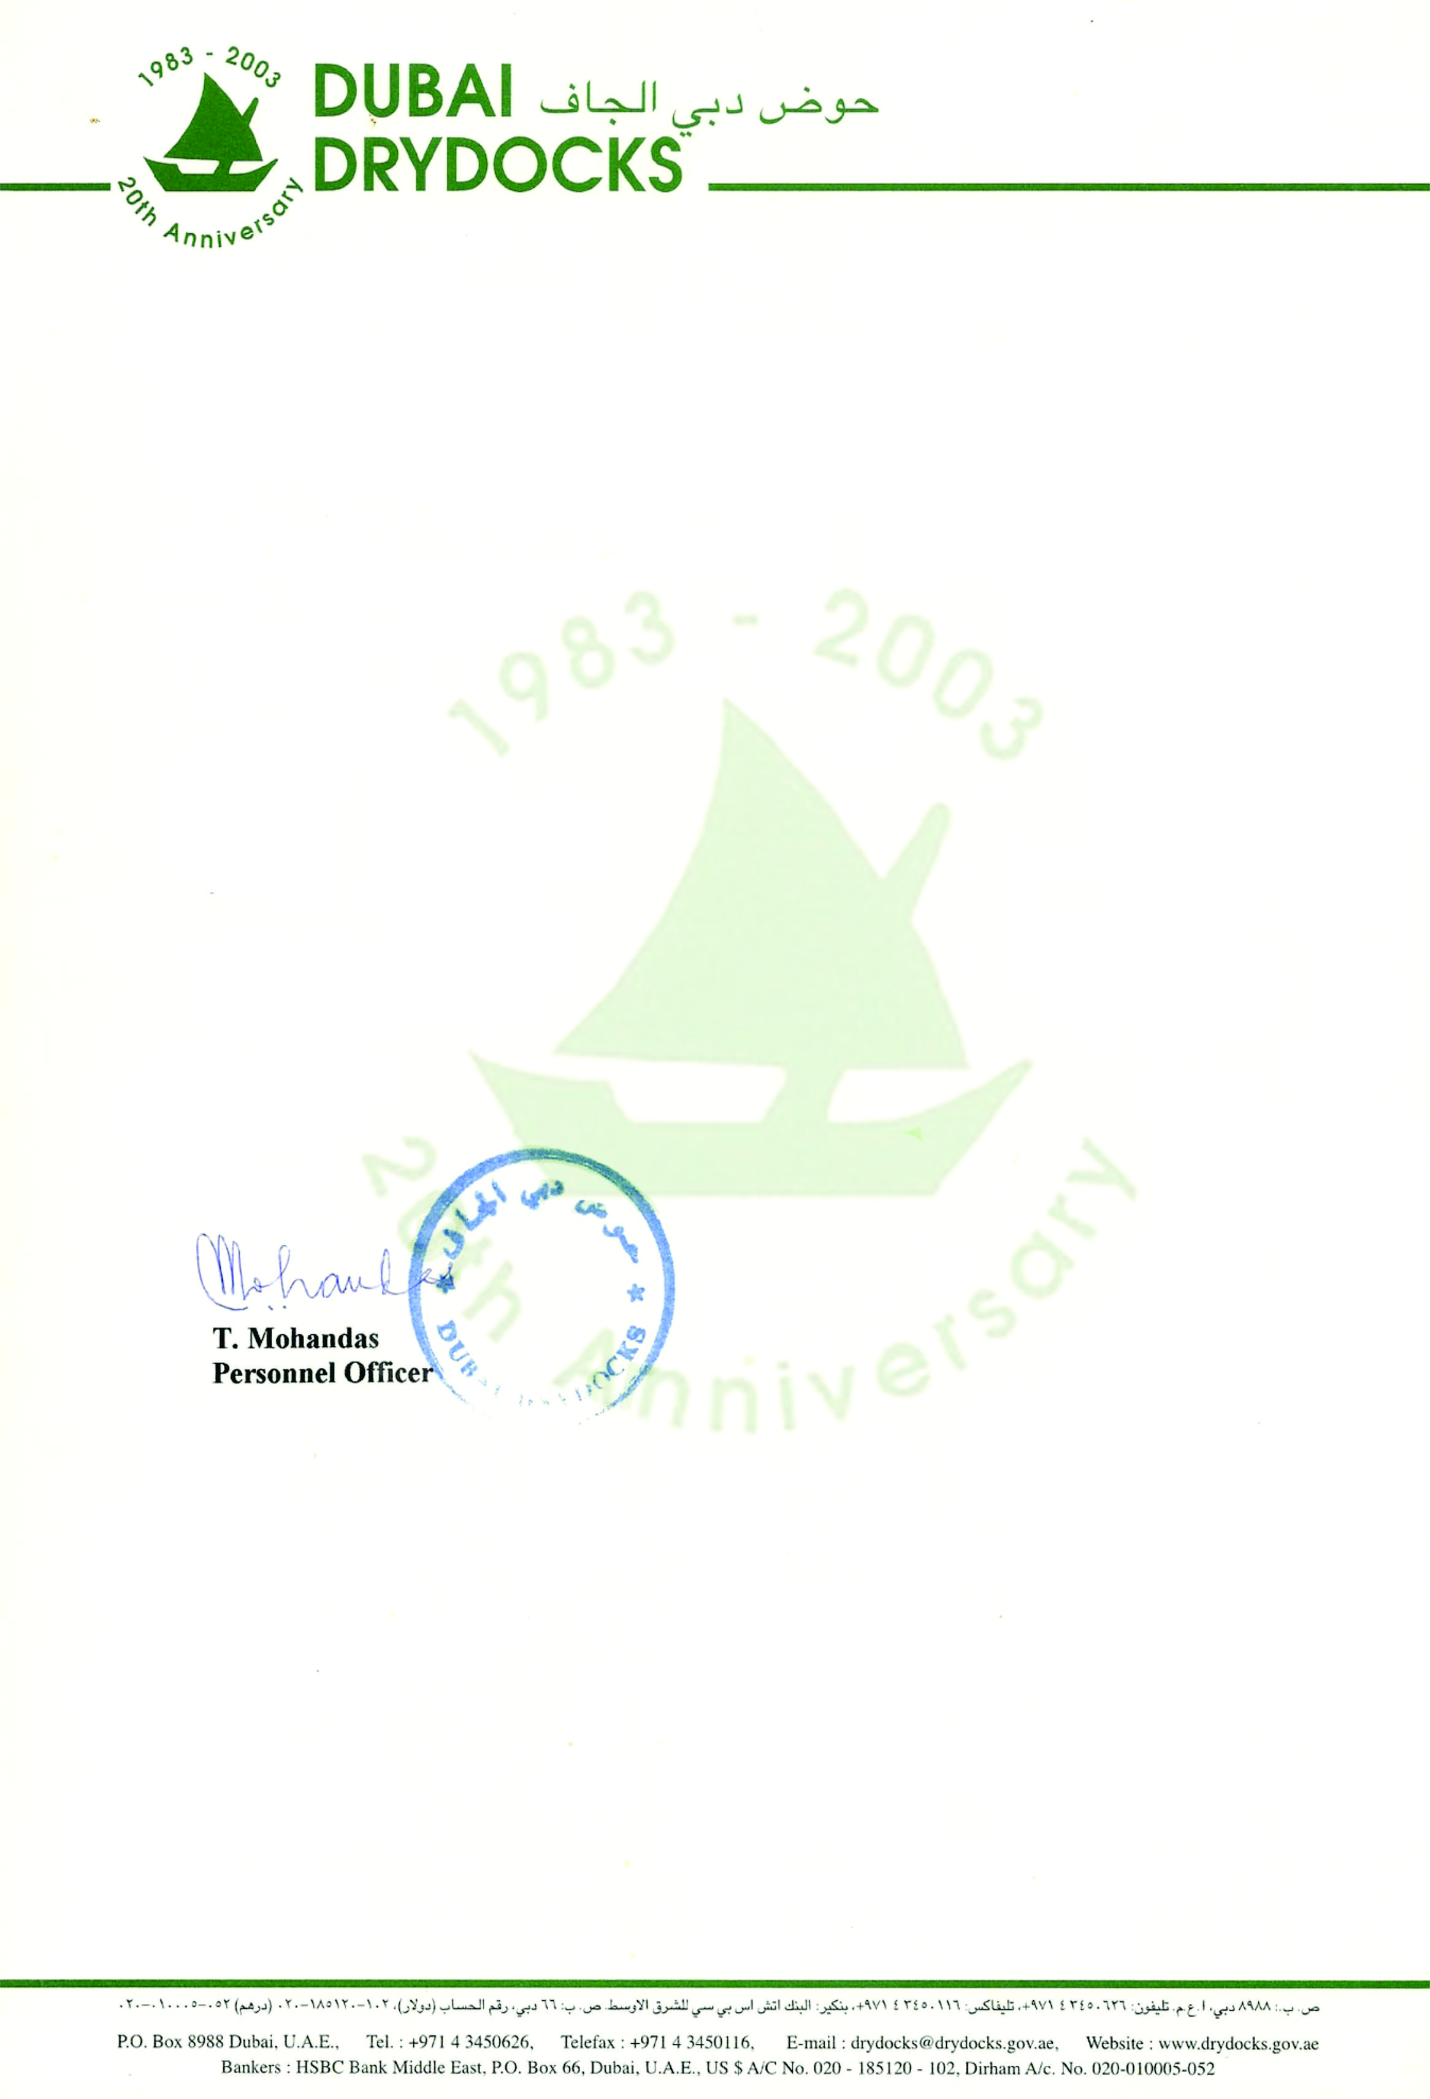

<To2> PERS/18737/2012

**TO WHOM IT MAY CONCERN**

This is to certify that Mr. <Name>, Pakistani National, holder of Passport No. <Passport>, was employed by Dubai Drydocks (an entity of the Government of Dubai) during the period <From2> to <To2>, as <Designation>, under Sub-contractor, Allied Services International (Pvt.) Ltd. In the Maintenance Department, at Dubai Drydocks Ship Repair Yard.

For further information please contact the Personnel Department of Dubai Drydocks.

For and on behalf of

DUBAI DRYDOCKS